Studio Arts:
Unit 4, AOS 3
Art Industry Contexts

Link to VCE Studio Art study guide
http://www.vcaa.vic.edu.au/Documents/vce/studioarts/StudioArtsSD-2017.pdf
All resources also available online at
http://visualartspace.weebly.com/galleries.html

Content
The Breakdown

This RESOURCE has been designed in a word document to make it easily editable and sharable amongst colleagues and students. Its primary role is to be used by teachers/students in UNIT 4: Outcome 3, either online or can be printed off as needed. Further details of the unit are provided on the next page.
1 > OUTCOME Overview (Teachers)
Teacher focused – Purpose of Unit plan and breakdown of VCAA study guide
2 > OUTCOME Overview (Teachers & Students)
Breakdown of the unit
3 > TIMELINE
Timeline with details regarding key skills & knowledge as well as class activities and resources for each week
Teachers can pick and choose what ideas they would like to use, example lessons are provided if needed
4 > RESOURCES & BIBLIOGRAPHY
Templates, worksheets, instructions to activities, practice exam papers etc
List of helpful resources including galleries to visit etc
All resources available online and access to google drive with documents below:
http://visualartspace.weebly.com/galleries.html
https://drive.google.com/drive/folders/0Bxvv-dpJs3nzM2lLa1JVS3o2aFU?usp=sharing

5 > CHECKLIST
Checklist of what to know before the exam
This is also explicit on the following page in ‘Key knowledge’ & ‘key skills’.
1 > OUTCOME Overview (Teachers)
Teacher details in line with study guide
VCE Unit 4
Area of Study 3
Art Industry Contexts
This area of study focuses on the key knowledge and key skills surrounding ART INDUSTRY CONTEXTS.
The unit has been designed so you the teacher, can pick and choose what and how you might implement various activities.
Unlike other previous units, this unit requires students to learn core terminology and associated issues surrounding art galleries rather than exploring their own ideas or experimenting with materials. For this reason, the outline for teacher and student is much the same.
On the completion of this outcome, your students should utilise appropriate terminology and understand/demonstrate the following:
Key knowledge – understand the…
• Methods & intentions of various art spaces
• Curatorial considerations, exhibition design & promotional methods involved in preparing and displaying artworks
• Methods & considerations of artists and curators working in galleries
• Conservation of artworks including lighting, temperature, storage, transportation and presentation of specific artworks
• Processes associated with the production, presentation and promotion of specific artworks in current exhibitions
• Characteristics of different types of gallery spaces
Key skills – demonstrate understanding by…
• Identifying & describing the characteristics of different types of gallery spaces visited in the current year of study
• Describing & comparing the methods of and intentions in exhibiting artworks in various galleries
• Analysing the presentation of artworks in different exhibitions
• Identifying & describing the purpose of artists and gallery curators and their intentions
• Analysing & evaluating curatorial considerations, exhibition design and promotional methods involved in preparing and presenting artwork
• Analysing & evaluating methods and considerations involved in the conservation of specific artworks

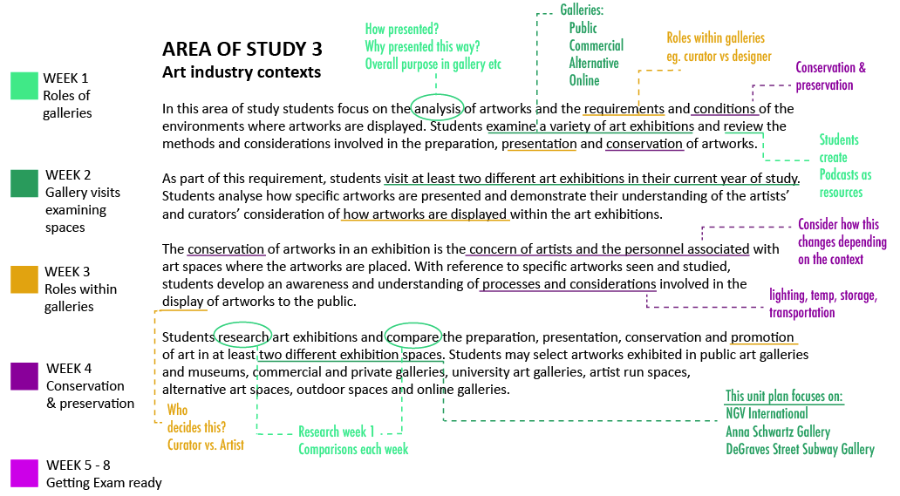
1 > OUTCOME Overview (Teachers)
Teacher focused - annotated breakdown of study guide
*Teachers might consider asking students to do the same process

VCE Unit 4
Area of Study 3
Art Industry Contexts
2 > OUTCOME Overview (Teachers & Students)
Breakdown of unit aimed at teachers & students

The Unit is comprised of various activities, designed to help build student knowledge and prepare students for their VCE exam.
In week 1, students are required to use research skills to collaboratively build their knowledge base, forming preparation for gallery visits in week 2.
During their visits to various galleries, students are provided with a ‘exhibition analysis sheet’ to flesh out their ideas and understanding of gallery spaces. An ‘Exhibition design’ template is also provided, asking students to truly examine the space and will serve as revision for later weeks.
Weeks 3 & 4 will be back in the classroom, unpacking the role of curators, designers and artists as well as the conservation and preservation considerations within each gallery space. Weeks 5-8 will be about preparation for the exam. This includes looking at the correct terminology required, linking words and sentence structure as well as practicing short answer responses. A sample exam paper is provided towards the end of this resource as well as revision questions in a recap powerpoint (this was provided by an ex-VCE Studio Arts assessor).
The one hurdle task for this unit is the creation of a 3-5minuite podcast.
The final assessment task is the end of year exam.
8 WEEK BREAKDOWN OF UNIT
> one lesson per week (70mins) excluding week 2 which may require a half or full day with students visiting galleries.
Week 1 > Methods and intentions of various art galleries including an overview
Week 2 > Visit to various galleries (At least one public, commercial and alternative art space)
Week 3 > Curator & designer roles, also promotion and marketing
Week 4 > Preservation & conservation (lighting, storage etc.)
Week 5 > Recap and review of all content covered
Week 6 > Writing techniques, including terminology and linking words
Week 7 > Short answer practice questions and exam prep
Week 8 > Review of areas not yet mastered and final exam prep

In addition to the activities listed for each week, I have designed an optional podcasting activity which covers weeks 1 to 4.

3 > TIMELINE
Breakdown of learning objectives
Gallery Resource  Unit 4 : AOS 3  VCE Studio Arts | Key knowledge | Key skills | Class activities | Resources & equipment required
Week 1  Methods  and  intentions  of various  art galleries  +  Overview  Galleries:  - public  - commercial  - alternative  - online | To discuss the methods and intentions of art galleries.  Touch on the processes associated with  production,  presentation &  promotion  of art  Use appropriate terminology. | Identify  &  describe  the characteristics  of  different  gallery spaces | Group activity - 4 groups in total is best  Each group is assigned a gallery type and must  research & collate their information.  - public – NGV International - commercial – Anna Schwartz  - alternative – Degraves Subway space - online - any  Considerations include 4 areas:  1) focus of exhibitions in that space - Media presented, theme and approach  2) Exhibition development & organisation  Purpose of exhibition, who is involved in the organising of the exhibition  eg. Transport?  3) Funding & promotion  Who sponsors/grants? Who is the promotion material directed at?  4) Conservation & Preservation  Measures taken to preserve work eg. Lighting, security, work placement  Students should research for a portion of the lesson, and then share their findings as a group to the class, later placing their resources online.  ** Worksheet ‘EXHIBITION ANALYSIS SHEET’ for week 2 has cues for questions.  Videos provided to support conversations around this weeks topic. | Student lead research  - computers/similar  +  ‘EXHIBITION  ANALYSIS SHEET’ available if prompting required  Video:  Why is public art important?  https://www.youtube.com/watch?v=tcVh-54gfVo  TED Talk Video:  Why do we need public art? | Nancy Ann Coyne  https://www.youtube.com/watch?v=yBPm7DWrTbI
Types of learning involved:
Social cognitive,
Inquiry-based
Week 1 – 4  Additional:  Podcasting | Podcasts  embed the content  of  each week  at  different stages  by  various students |  | Individual activity – runs for total of 4 weeks  Each student is assigned one week in which they must produce a 3-5min podcast about the topic of that week.  The podcast can be created using Voice memos or similar and editing can be done in Audacity. Online materials are supplied to help students with this task.  The purpose for the podcast is for students to use high level thinking skills by organising and re-interpreting content. This process will aid memory retention and serve as a revision tool for the other members of the class.  Students need to upload their podcasts online (I suggest you use something like Weebly) so other students can listen and revise during the week.  * I recommend they listen to podcasts while eating breakfast or getting ready  * Teacher should carefully consider which students present during which week  * Podcasts not to be recorded in class time | http://visualartspace.weebly.com/ict-tools.html  +  Students to find additional resources  + content on podcasts can be drawn from the resource sheets each week.
Types of learning involved:
Inquiry-based,
links to Blooms Taxonomy

Below is a table that can be used to assign and monitor students completing a podcast each week.
Podcasting:  Student created revision  > 3-5min recorded podcast | Week 1:  Roles of galleries | Week 2:  Examining spaces | Week 3:  Roles within galleries | Week 4:  Conservation & preservation | Completion of podcast  Y/N
Student x
Student x
Student x
Student x
Student x

Gallery Resource  Unit 4 : AOS 3  VCE Studio Arts | Key knowledge | Key skills | Class activities | Resources & equipment required
Week 2  Excursion  to  gallery  spaces  1)  NGV Int/Australia  (public)  2)  Anna  Schwartz  gallery  (Commercial)  3)  Degraves  street  subway  gallery  (alternative) | To discuss the curatorial considerations, exhibition design.  Discuss  promotional methods  involved in preparing and  displaying artworks  Use appropriate terminology. | To describe & compare  the methods of  exhibiting  artworks.  To describe & compare the  intentions  in  exhibiting  artworks  in all  gallery spaces discussed | Class activity – Each student chooses a pair to work with during the day  Students visit 3 galleries :  A sample Itinery provided below and in resources folder.  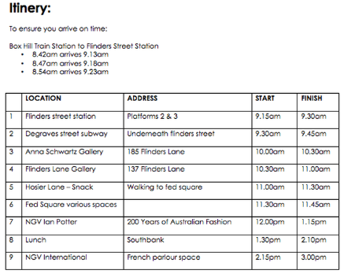  Students visit galleries filling out sheets provided (online or printed on paper)  The worksheets require the students to question things about the gallery and observe and record the space.  * Students to go into smaller gallery spaces in little groups | All students to bring packed lunch or buy lunch  Pencil x 2  Paper for notes  Handouts to be printed  *optional  Students to draw using a program called ‘Doceri’ with the ipad  Resource with details and examples online…  http://visualartspace.weebly.com/galleries.html  Anna Schwartz gallery  http://www.annaschwartzgallery.com/gallery?c=m  DeGraves Street subway  http://www.cv.vic.gov.au/blog/archive/degraves-street-subway-and-campbell-arcade-the-underground-artspace/  Flinders Lane Gallery  http://www.annaschwartzgallery.com/gallery?c=m  NGV Ian Potter  NGV International  http://www.ngv.vic.gov.au/
Types of learning involved:
Experiential learning,
Dual coding theory

Gallery Resource  Unit 4 : AOS 3  VCE Studio Arts | Key knowledge | Key skills | Class activities | Resources & equipment required
Week 3  Curator  &  designer  roles  +  promotion  and  marketing | Study the  processes associated with the  production, presentation  and  promotion  of specific  artworks  in current exhibitions  Use appropriate terminology. | To analyse how specific artworks  are  presented in different  exhibitions.  To demonstrate an understanding of the  artists’  and  gallery curators’ intentions  To analyse & evaluate  curatorial considerations, exhibition design  and  promotional methods involved in  preparing+ presenting specific artworks  for display | Group activity – Students split into groups of 3  Teacher to hand out ‘STAFFING ROLES IN GALLERIES’ and to discuss with class.  In their groups, students then need to study the content provided and prepare 20 questions for another small group of 3.  Groups will then quiz each other on the content.  Some of the learning this week needs to be rote learning to ensure students memorise terms and specific concepts.  The following practical lesson, students should be given a pop quiz regarding all the content they have learnt till this point (use a selection of student questions)  Videos all supplied to aid content.  REVIEW QUESTIONS are provided to help with this week.  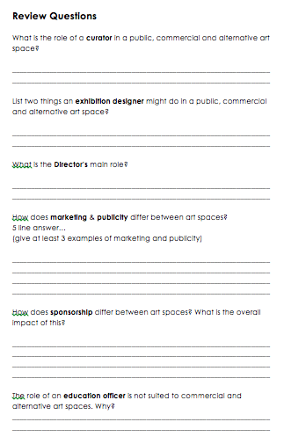- sheet provided can be printed off separately | Computers required  ‘STAFFING ROLES IN GALLERIES’ handout  Also ‘REVIEW QUESTIONS’ are provided at the bottom of the ‘STAFFING ROLES IN GALLERIES’ handout  *Handout there to check student understanding.  Video’s provided by the NGV, students should watch for homework.  http://www.ngv.vic.gov.au/multimedia/curating-art-art-start/  http://www.ngv.vic.gov.au/multimedia/exhibition-design-art-start/  Prezi found online  https://prezi.com/rnruqkfuepc6/roles-and-processes-in-galleries-and-exhibition-spaces/
Types of learning involved:
Vygotsky, Scaffolding,
Flipped classroom

Gallery Resource  Unit 4 : AOS 3  VCE Studio Arts | Key knowledge | Key skills | Class activities | Resources & equipment required
Week 4  Preservation  &  conservation  focus | Study the methods used by  and  considerations  of artists + curators working in galleries  in  conservation of  artworks  This includes:  lighting,  temperature,  storage,  transportation +  presentation  of  artworks  Use appropriate terminology. | To analyse  and evaluate methods  and  considerations involved in the conservation  of  specific artworks related  to  exhibitions  visited | Teacher to go through a couple of key points using resource provided…  Preservation and conservation includes these areas:  Maintaining stable temperature  Maintaining relative humidity levels  Managing light exposure  Controlling pests  Disaster preparedness  Protecting works of art from other physical or chemical damage  Resource provides specific details for:  PHOTOGRAPHS  WORKS ON PAPER  PAINTINGS  Teacher should discuss effects and students can review notes and then research into one key area eg. Related to their studio work.  ** All students must review a painting as this is likely to be in exam.  Teacher might want to provide a series of images and get the students to annotate the effects and how to avoid such damage.  ‘Other forms of damage’ section can be used for that activity.  Conservation and Preservation KEY TERMS should be emphasised  (Summary at very bottom of ‘CONSERVATION AND PRESERVATION’ doc.)  Students need to watch 4 small videos provided by the NGV for homework. | Computers required  Resource word doc. ‘CONSERVATION AND PRESERVATION’.  National Gallery of Australia  http://nga.gov.au/Conservation/prevention/index.cfm  http://nga.gov.au/Conservation/prevention/photos.cfm  Video links to watch for homework:  National Gallery of Victoria  https://www.youtube.com/watch?v=tMbVfweQcW4  https://www.youtube.com/watch?v=etqe89wEU5w  https://www.youtube.com/watch?v=SP0yJYjE7L  https://www.youtube.com/watch?v=F8i7RSFggmY
Types of learning involved:
Research skills, social cognitive,
flipped classroom

Gallery Resource  Unit 4 : AOS 3  VCE Studio Arts | Key knowledge | Key skills | Class activities | Resources & equipment required
Week 5  Recap  +  review  of  all  content  covered to date | All knowledge up to date.  Focus on comparing data. | All skills up to date.  Focus on comparing data. | Pair activity – Students work in 2/3’s  Students are provided with a table, comparing information from all areas studied, they need to sort the information into 3 categories:  Public  Commercial  Alternative  **Teachers might want to fill in some areas or leave the table entirely blank depending on students cognition.  Class to discuss answers once pairs have completed the table.  Depending on time, Teacher might want to run through specific areas and get students to start doing some short answer questions based on the table information.  Use the art terminology handout to test students on metalanguage  eg. Mixed media – get students to describe what that actually means and give an example.  eg. Relative humidity – what is this and what % does it need to be in a gallery?  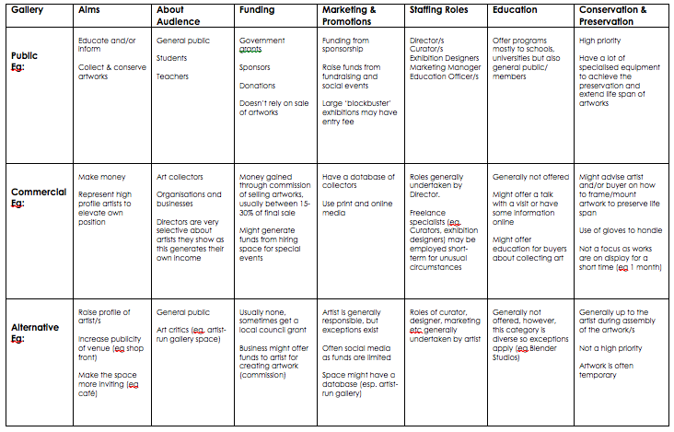  - compare table | Computers required  Resource word doc. ‘GALLERY COMPARE ACTIVITY TABLE’.  Also  ‘ART TERMINOLOGY’ handout provided  Pens/pencils  Table can be filled in online or by hand if printed.
Types of learning involved:
Social cognitive, Links to Blooms Taxonomy with categorising content

Gallery Resource  Unit 4 : AOS 3  VCE Studio Arts | Key knowledge | Key skills | Class activities | Resources & equipment required
Week 6  Writing  techniques  +  dissecting terminology  and  linking words | Identify  describe  compare  analyse  evaluate  Content covering weeks 1-5 | Identify  describe  compare  analyse  evaluate  Content covering weeks 1-5 | Teacher to go through checklist of knowledge and skills learnt.  Teacher to Quiz students on main areas (using resources as guide) and together class to negotiate key terms to mention in the exam for each area.  Students to brainstorm linking words in small groups… Teacher then will create a word list and get students to race writing as many linking words they can think of in the next few lessons.  This will help a lot when answering short answer questions.  *TIP: Students should place vocab list next to bed and read a few times before they head to bed leading up to the exam.  ALSO, during this lesson the teacher can go through the past exam papers and the examiners report.  Dissecting areas not done well and difficult questions is suggested.  Find the reports online here:  http://www.vcaa.vic.edu.au/Pages/vce/studies/studioarts/exams.aspx | All resources to be used as reference  Thesaurus for linking words and google online  Past exams and examination Reports  http://www.vcaa.vic.edu.au/Pages/vce/studies/studioarts/exams.aspx  Also  ‘ART TERMINOLOGY’ handout provided
Types of learning involved:
Social cognitive, Analysis of
past exam papers crucial

Gallery Resource  Unit 4 : AOS 3  VCE Studio Arts | Key knowledge | Key skills | Class activities | Resources & equipment required
Weeks  7 – 8  7 >  Short  answer  practice questions  +  Exam prep  8 >  Review  of areas  not yet mastered  +  Final exam prep | Identify  describe  compare  analyse  evaluate  Content covering weeks 1-5 | Identify  describe  compare  analyse  evaluate  Content covering weeks 1-5 | Pop Quiz activity – Students complete questions on powerpoint upon entry into class… must be quiet  Teacher to go through final powerpoint slides as revision.  Teacher can use this last week however they feel best.  possibly get students to read sections and then discuss in groups, I would suggest students mark off areas they are unsure of as you go through it.  Review of online galleries eg. Moma – get students to look these up.  There are a number of past exam questions (provided in this resource by an ex-exam assessor)  Pick and choose what questions might be useful to go through with your students.  Powerpoint on ‘EXAM PRACTICE’ available in resources.  Practice exam paper  Students to complete in silence as practice exam conditions | Computers required  resource ‘FINAL WEEKS QUIZ & REVISION’ provided.  Powerpoint on ‘EXAM PRACTICE’ available
Types of learning involved:
Scaffolding

4 > RESOURCES & BIBLIOGRAPHY
Templates, worksheets, instructions to activities, practice exam papers etc
List of helpful resources including galleries to visit

Core Resources:
Google drive with all resources
https://drive.google.com/drive/folders/0Bxvv-dpJs3nzM2lLa1JVS3o2aFU?usp=sharing
All resources provided online at:
http://visualartspace.weebly.com/galleries.html
Link to VCE Studio Art study guide
http://www.vcaa.vic.edu.au/Documents/vce/studioarts/StudioArtsSD-2017.pdf
Galleries to possibly visit for this outcome – listed from Public to Alternative:
Public
National Gallery of Victoria – International and Ian Potter Center
http://www.ngv.vic.gov.au/
Student program available at NGV - $25 per student
http://www.ngv.vic.gov.au/program/vce-studio-arts-unit-4-art-industry-contexts-2/
Australian Centre for Contemporary Art (ACCA)
(there may be a combination of alternative space artwork and public gallery artwork)
https://www.accaonline.org.au/
Australian Centre for the Moving Image (ACMI)
https://www.acmi.net.au/
Heide Museum of Modern Art - State-owned public museum and gallery

https://www.heide.com.au/
RMIT Gallery - Australian public art gallery
http://www.rmit.edu.au/about/our-locations-and-facilities/facilities/exhibition-spaces/rmit-gallery
Margaret Lawrence Gallery – linked to the Victorian College of the Arts
http://vca.unimelb.edu.au/engage/margaret-lawrence-gallery
Commercial – lots of these scattered around the city so pick and choose as you like.
I recommend these.
Flinders lane art gallery
http://www.flg.com.au/
Anna Schwartz gallery – commercial gallery
http://www.annaschwartzgallery.com/gallery?c=m

ARC ONE gallery - commercial gallery that represents some of Australia’s most highly respected contemporary artists
http://arcone.com.au/
Langford art gallery
http://www.langford120.com.au/
Alternative
Chapter House Lane - non-profit contemporary art organisation (reopens later 2016)

http://chapterhouselane.org.au/

fortyfivedownstairs is a Melbourne based not-for-profit theatre and gallery
http://www.fortyfivedownstairs.com/wp2016/
CAVES gallery - not for profit contemporary art space
http://www.cavesgallery.com/

Blindside Gallery - independent contemporary arts space committed to supporting and promoting contemporary art practice
http://www.blindside.org.au/
Degraves street subway – gallery below flinders street station
http://www.cv.vic.gov.au/blog/archive/degraves-street-subway-and-campbell-arcade-the-underground-artspace/
No Vacancy Gallery - Melbourne-based hire-gallery that promotes and exhibits emerging local and international artists.
https://no-vacancy.com.au/

TwentybyThirty – not for profit, artist-run initiative
http://www.thatsmelbourne.com.au/Placestogo/Galleries/Public/Pages/7257.aspx
Dark horse experiment - artist run project space
http://darkhorseexperiment.com/
HOW to Podcast:
https://www.youtube.com/watch?v=-hrBbczS9I0
Blended Bibliography – In order of how useful resources were, APA style for books towards bottom.
Victorian Certificate of Education: Studio Arts Study guide. 2016 Victorian Curriculum and Assessment Authority 2016, Melbourne
National gallery of Australia
http://nga.gov.au/Conservation/prevention/photos.cfm
Art gallery NSW
http://www.artgallery.nsw.gov.au/discover-art/how-the-gallery-works/conserving-our-collection/
National Gallery of Victoria
https://www.ngv.vic.gov.au/explore/collection/conservation/
videos 1 - 4
https://www.youtube.com/watch?v=tMbVfweQcW4
https://www.youtube.com/watch?v=etqe89wEU5w
https://www.youtube.com/watch?v=SP0yJYjE7L
https://www.youtube.com/watch?v=F8i7RSFggmY
MetMuseum New York
http://www.metmuseum.org/about-the-met/conservation-and-scientific-research/objects-conservation
http://www.metmuseum.org/~/media/Files/Learn/Family%20Map%20and%20Guides/MuseumKids/What%20is%20Art%20Conservation.pdf
https://www.britannica.com/art/art-conservation-and-restoration
AICCM Australian Institute for the Conservation of Cultural Material
https://aiccm.org.au/
Government website on role of galleries, artists etc
http://creativeaustralia.arts.gov.au/archived/module/appendix-a/the-central-role-of-galleries-libraries-archives-and-museums/
http://creativeaustralia.arts.gov.au/archived/module/appendix-a/recognising-the-artist-as-central/
http://creativeaustralia.arts.gov.au/archived/module/the-australian-story-a-vision-for-australias-cultural-sector/the-role-of-the-artist/
Degraves street article
http://www.cv.vic.gov.au/blog/archive/degraves-street-subway-and-campbell-arcade-the-underground-artspace/
Article on curating gallery spaces
https://theeclipsegallery.wordpress.com/about/writing/curating-alternative-spaces/
Links to ideas on curation, artists processes etc
http://www.axisweb.org/
Arts council – England
http://www.engage.org/jobs-in-galleries.aspx
Prezi found online also helpful
https://prezi.com/rnruqkfuepc6/roles-and-processes-in-galleries-and-exhibition-spaces/
Readings – these were surprisingly the least useful as they had a lot of jargon in them, best resources were the websites of public galleries:
Bibeau, Petra Royale. (2016). What Alternative Space? The Outgrowth of the Alternative and Exhibition Practice.
Retrieved from: http://blog.maniacgallery.com/?p=27&gt
Joy, A. (1996). Framing art: the role of galleries in the circulation of art.
Retrieved from: http://repository.ust.hk/ir/bitstream/1783.1-873/1/mktg96061.pdf
(this gets into a lot of detail – ‘manipulation of space’ and ‘conclusions’ most helpful)
Ford, M. (2003). The Journey Continues: Stain and Washing of Asian Textiles. Artonview 32, Summer 2002-2003, p 53-55.
(Good overview with textiles focus)
Roberts, S., Camic, P. M., & Springham, N. (2011). New roles for art galleries: Art-viewing as a community intervention for family carers of people with mental health problems. Arts & Health, 3(2), 146-159.
(good link to Art anxiety and purpose of art galleries in this sense)

5 > CHECKLIST
Checklist of what to know before the exam

To be ready for your exam,
you must be able to….
1 – List the methods and intentions of various art galleries – must know public, commercial and alternative galleries.
2 – Explain the processes associated with production, presentation & promotion of art – must give one detailed example
3 – Describe the characteristics of various gallery types
4 – Compare curator and designer roles
5 – Explain in detail how you must preserve and conserve an artwork
6 – List conservation terms and understand their meaning
7 – Pinpoint what the question is asking you and remember the ‘LOADED TERMS’ you should mention to get top marks
8 – Use appropriate and varied linking words in your sentences
The following must be competed before you sit your exam:
1 – Have practiced timing yourself with a number of short answer questions
2 – Finished and checked the practice exam paper provided as well as reviewed last year’s exam questions.

