Texture

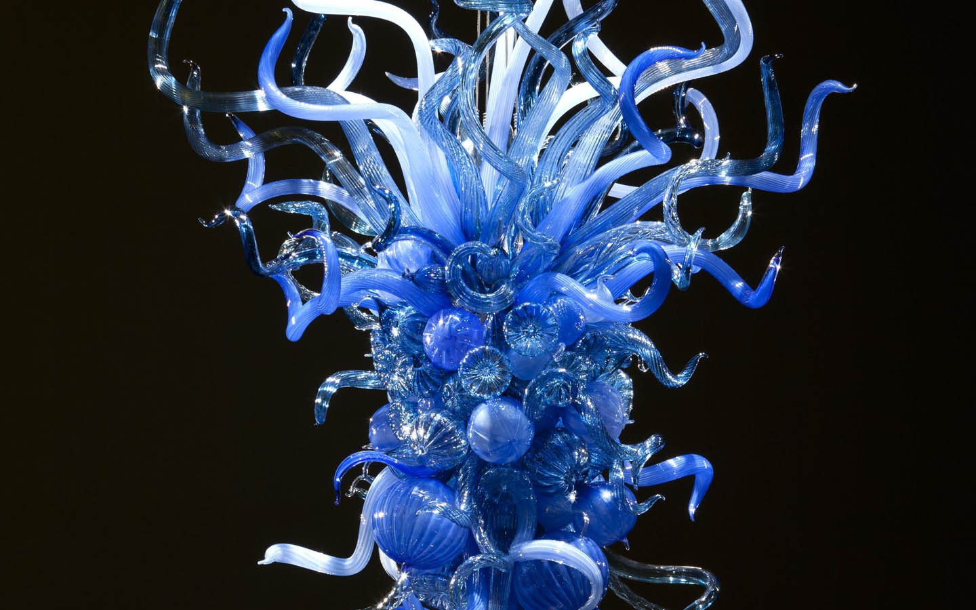
Plate 1 Dale Chihuly, Blue Dusk Chandelier (2011) Blown glass
See detail below
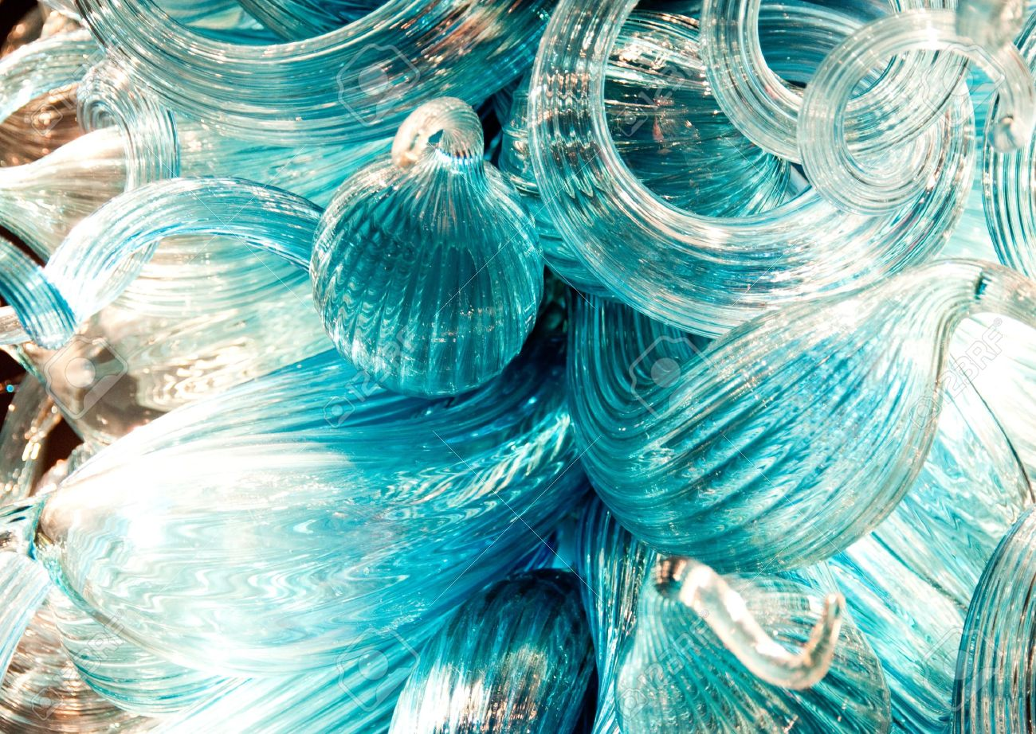

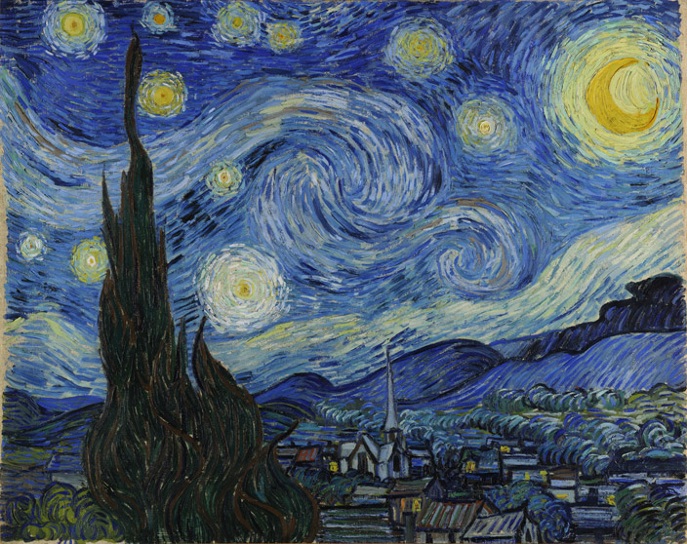
Plate 2 Vincent van Gogh, The Starry Night (1889) Oil Paint on Canvas
See Detail below
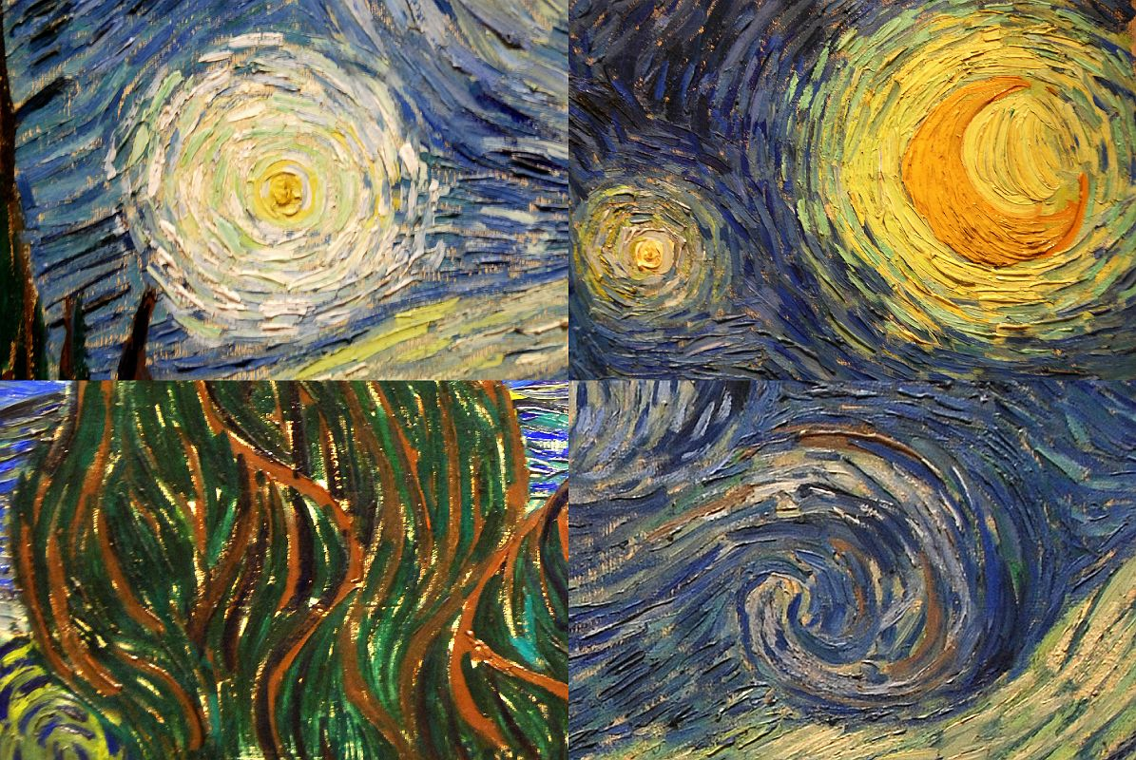

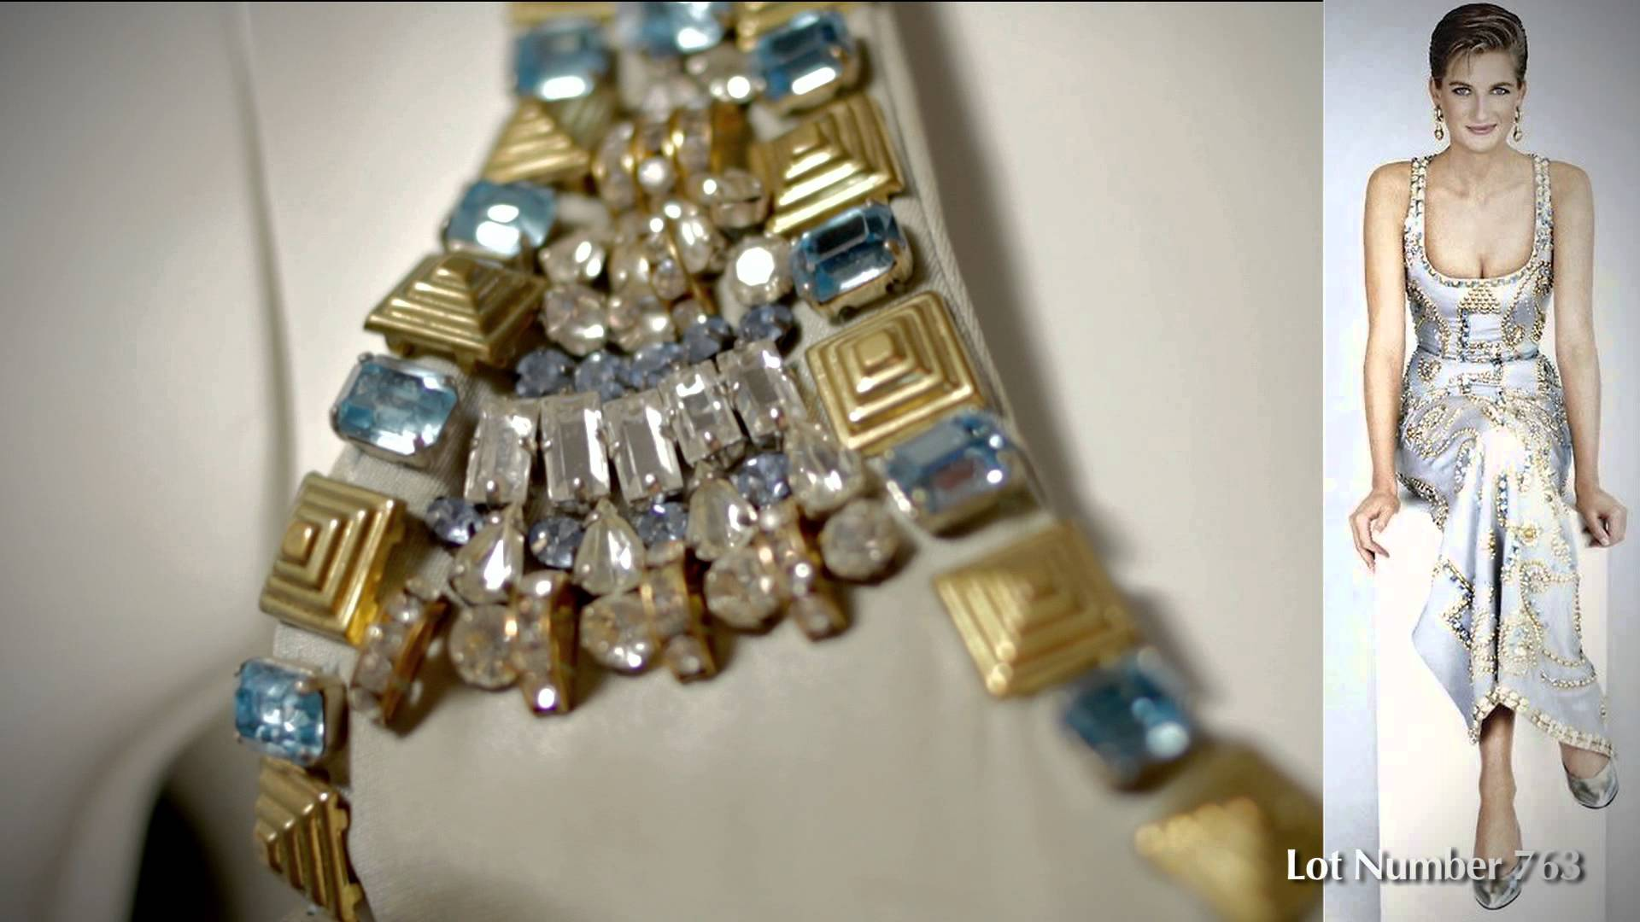
Plate 3 Gianni Versace Gown designed for Princess Diana (1991) Silk, Costume jewellery

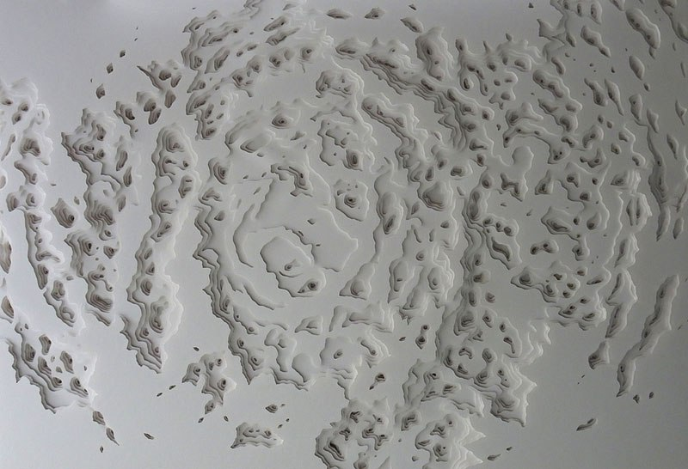
Plate 4 Rogan Brown Title Unknown (2014) Paper
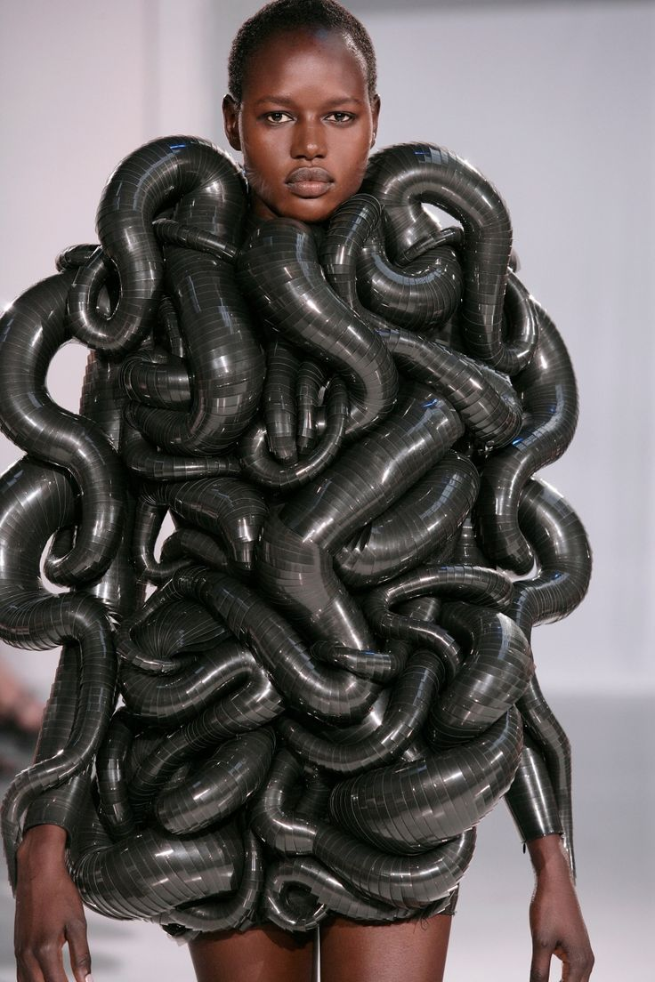
Plate 5 Capriole (2014) Black Acrylic sheets
See detail below

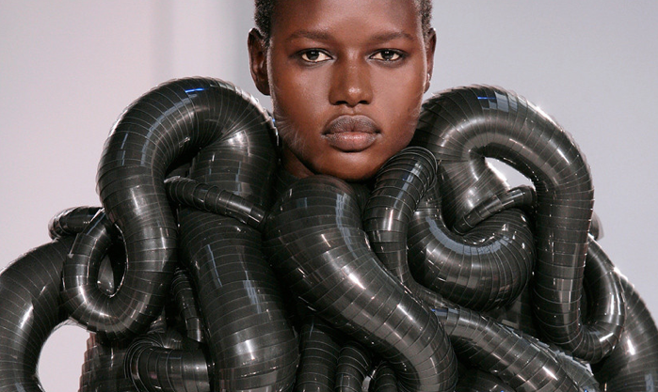
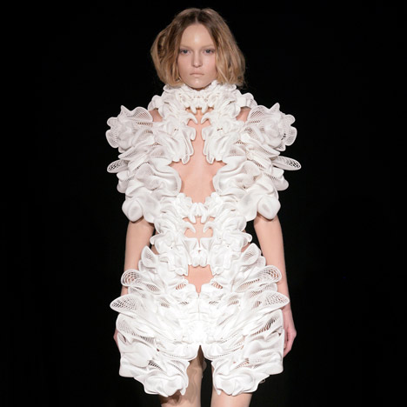
Plate 6 Title Unknown (2010) 3D Printing
See detail below
