Lesson Plan & Reflections
Date: 18/10/2016 (lesson taught with Chris)
Resource available as a PDF attachment and online at:
http://visualartspace.weebly.com/screen-printing.html

Lesson  Topic | Textile Year 10 Unit > 70mins  Screen printing:  Creating abstract shapes working towards a textile application
Lesson summary | Textile Year 10 Unit > Visual Arts  This lesson requires students to build their knowledge of screen printing processes to create a number of collaborative artworks.  After a quick introduction to the class, students grab their previously prepared stencils ready to start the print process.  The lesson runs through the process of creating a screen print for the design created (through the use of stencils).  The first step is to transfer the stencil onto the screen via masking tape (ensure there are no bubbles and paper is pulled tightly)  Second step is to align the screen with the registration marks created for the screen (in previous lesson).  Third step was to Flood the screen and then begin screen printing onto paper.  Each student group will print two screen colours and then all groups will look at how they can combine their artworks (swap screen etc). This will lead to a number of abstract artworks that will then form the basis for a textile print.  So this lesson is about learning the process and developing procedural knowledge in terms of screen printing.  The following lesson will allow students to combine their knowledge and created screens to transfer their prints onto textiles.
Link to  Curriculum  Standards | This lesson was designed to follow on from the previous lesson where students looked at artists who used similar processes (eg. Matisse). In the previous lesson, students also had an opportunity to create their final stencils and become familiar with the screen printing process before the class. Discussion time for questions and planning is provided in the previous lesson as well as considerations for pack up and cleanup to ensure the screen printing lesson runs smoothly.  Victorian Curriculum (VC), Visual Arts strand, Standard 9 & 10.  The context for this lesson is situated around the VC component of ‘Explore and Express Ideas’ or more specifically ‘explore ideas, experiences, observations and imagination to create visual artworks’.  Students are therefore required to explore the visual art practice of screen printing, expressing concept ideas and aesthetics towards the development of a personal style.  The screen printing lesson also addresses the ‘visual Arts Practices’ component, where students ‘Experiment with different materials and techniques to make artworks’. The lesson uses a number of traditional screen printing materials but also has flexibility in that students can trial alternative methods to alter their stencils, application of paint and final effect of their artwork. The students can have a concept before engaging in their artistic process, this is up to the individual.
Context | This screen printing lesson is situated within a larger unit of Textiles. The year 10 class will be working towards creating a final t-shirt graphic that may be a mix of processes including, digital design, drawing and screen printing. The lesson is completed about half way through the unit, giving students opportunity to reflect on their process and how they might use screen printing for their final outcome. The key focus on the lesson is to explore materials, processes and collaborate in their learning.
Learning  Outcomes  (Students) | Students should be able to:  Design… abstract artworks and collaborate with others in creating a final artwork. Then they will be challenged to screen print a number of stencils and again, combine their artwork (screens) with other groups to make a number of final artworks.  Reflect… on their design ideas and analyse what aesthetic will work collaboratively.  Develop…a series of screen prints, both in pairs and within a group setting.  Demonstrate… an understanding of screen printing processes, including the steps, approach and delivery of final outcomes.  Create… A number of screen prints, both as a pair and as a team (collaboration key).
Learning  Outcomes  (Teacher) | I should be able to:  Evaluate… Student understanding of the medium and processes during the lesson. This could be through assessing their techniques, application and approach.  Guide…students to think about questions relating to their process, materials and aesthetics of their work. I would also be asking them questions based on holistic development such as “how can you ensure you whole group is included in this activity?”  Facilitate…Individuals to respect and keep the learning space a safe one. Also facilitate cohesion between groups and support a strong link between process and creativity.
Teaching  Resources/Materials | Equipment list is provided on the weebly but also on the resource. See list below.  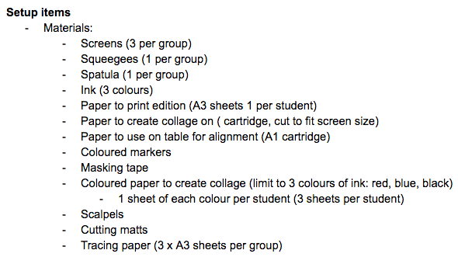
Previous  Lesson: | In the previous lesson, students worked on creating a 2 colour screenprint in a small groups (2-3 per group ideally). They collaged coloured paper to create abstract shapes, observed how other artists might go about screen printing as well as finalising their stencils for the printing process.  By the end of the previous lesson, students needed to trace and cut out all stencils, ready for the next lesson.  The first page of the resource outlines the steps taken in the previous lesson…  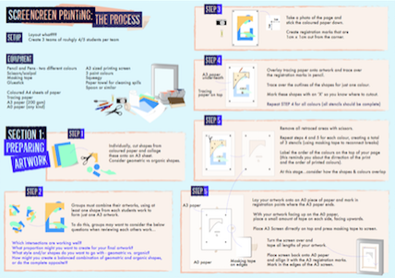  *** Group numbers depends on time allocated in unit plan and also number of screens available.
Key  Questions/Big  Ideas: | Questions are outlined on the resource… some of these include:  Questions during process:  Which intersections are working well?  What proportion might you want to create for your final artwork?  What style and/or shapes do you want to go with – geometric vs. organic?  How might you create a balanced combination of geometric and organic shapes… Or do you stick to one style?  Other things you might ask students include:  How might the students design roles for the class eg. Who cleans what? Who takes over what roles? How might it be best to share the roles equally?  Questions around reflective thinking would also be beneficial. Some include:  Could the process be improved and how could you adjust the steps and lesson to do this?  If you could adjust anything in the lesson what would you change?  What parts of the lesson did you learn the most?  Which parts of the lesson did you feel you already knew?  Did all students get a chance to participate?  If not, how could you ensure all students had a turn in various stages?

Instructional Strategies

What will the teacher do? | What will students do?
Intro:  5mins  Breakdown of lesson with students, identifying the main equipment and safety precautions.  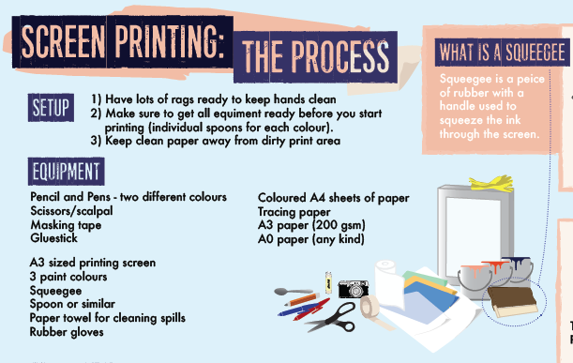 | Listen and acknowledge respectful use of equipment and safety
5mins  Teacher explains and demonstrates taping method for stencils  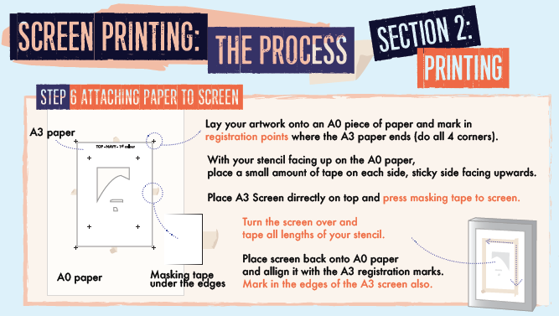 | Students tape stencils in groups.  Also check materials are ready, aprons on, gloves etc
20mins (5 min demo, 15 min process)  Explanation of marking screen, students copy process. Teacher also goes through how to work together to complete screen print eg. One holds down, one collects paper, one adds paint, one pulls squeegee…  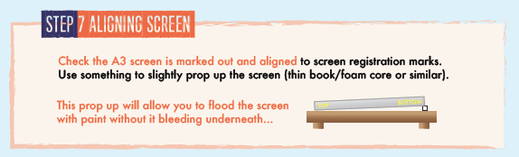  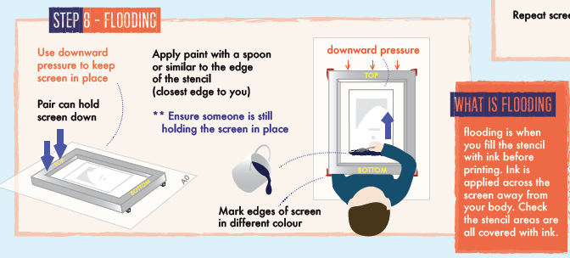 | Students copy teacher activity  Work in teams to ‘Flood the screen’.  Students asked reflective questions about purpose of ‘Flooding’….  CRITICAL THINKING Q’s  eg.  Why do we need flooding?  Why do we prop up the screen before printing?  Do all the holes in the screen have to be covered? Why? How can you check this??
20mins (5 min demo, 15 min process)  Explanation of marking screen, students copy  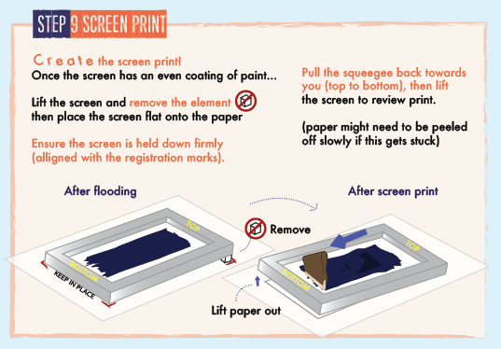 | Students work in teams to create screen prints for their 1 screen  complete second screen if time, otherwise after debrief.
5mins  Reflection time:  Teacher asks students to have a look at their prints and reflect on their process…  What aesthetics do they like?  What colours overlap well?  What might they want to add next?  Would they consider flipping the screen?  Is their print area nice and clean to avoid contamination? | Students reflect  - answer questions of process, aesthetics, collaborative work and learning  - think about bleeding on screen… was the paper not pulled tight enough OR is it dodgy paint?  Students should consider answers…
Teacher facilitates – 10-20mins depending on time taken for other activities to date, play by ear.  ** remind students about drying artwork and checking with finger to see if the second colour can be applied  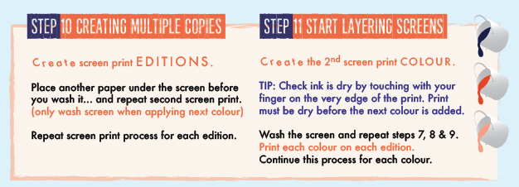 | Students complete second and or 3rd colour print depending on time and number of screens.
5-10min  Teacher facilitates packup  Directs students and tables to be in charge of certain areas to clean up etc.  **Reminders on board for things to do…  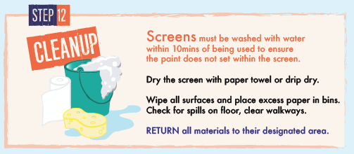 | Students packup  Ensure all screens cleaned and dried or drip dry  paper in bins  Wiped surfaces and floor clear of spills  Return materials to designate areas…  End of class.
Reflection & Evaluations:
Students and teacher should consider what outcomes were achieved?
To what extent?
What could be improved for future lessons?
Consider all segments of the lesson, from intro to process to clean up…
What goals can be set to achieve these?
Students should mention in relation to the specific materials and techniques but also holistic development.
Did pairs work well together?
Was it easy to collaborate with other groups when making a combined artwork? Why or why not?
Forward thinking…
How may students use their artwork in a digital space to get a textile print?
Would they consider combining both digital print and textile print for a final outcome?
Resources
Resources on next page (can be resized) and online at:
http://visualartspace.weebly.com/screen-printing.html

