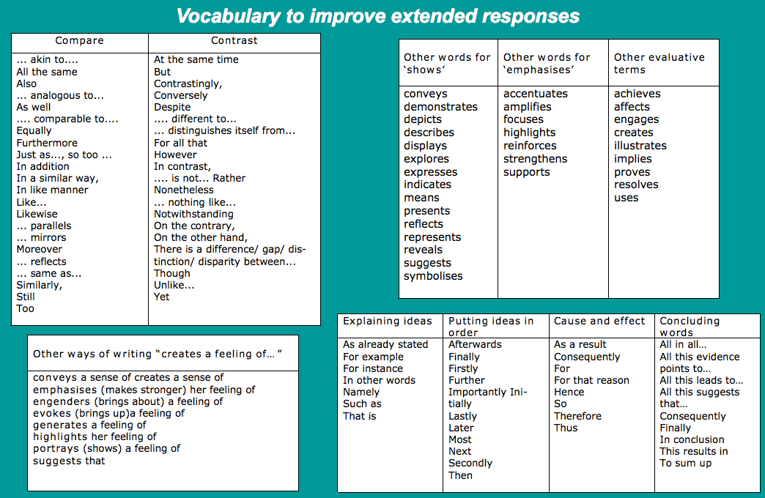

Source : http://hsc.csu.edu.au/english/esl/texts/elect1/4039/2vocabimprove.pdf Accessed 23/02/2015

