Design Specifications Freelance

General Specifications
- Repeat tiles are to be 250 dpi RGB. Document Type: Save as PSD files.
File Numbers
- You will be given a designer number, which you will allocate to all new files and will continue sequentially.

Finished Files should include the following layers:
Layer 1: REPEAT TILE
Each repeat tile needs to be a seamless, side-to-side repeat.
Note: If the repeat tile varies from being side to side, please make note on the layer name
Example: REPEAT TILE (half drop).
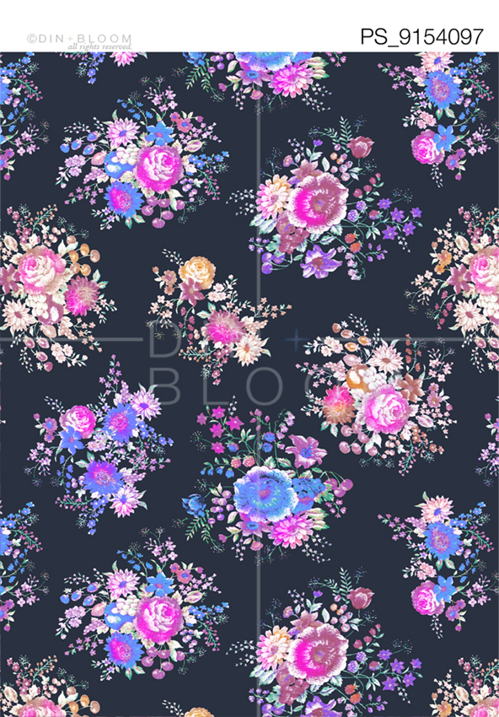
General Notes
When finishing a file and before final sign off please make sure you check the following:
- All repeat tiles need to be flawless and production ready. Please double check there are no colour variations or fine ‘ghosting’ where the tiles join.
- Repeat example need to be seamless, so please check that there are no ‘tram tracks’ running through the layer and that the colour is consistent.
- All files should be labelled as outlined above. No other extensions or names should be included in the file.
- All layers in files should be labelled as outlined above and always be in CAPS.

Payment Terms
As per this agreement, payment will only be made after we have received all files finalised exactly as above specification. Please submit your invoice with your weekly uploaded final designs; payment will be completed within 21 business days.

Please note; through receiving these specifications and agreeing to enter into a trial brief you acknowledge and consent to the below.
The Designer agrees to preserve and protect the confidentiality/non disclosure of the Company’s proprietary information and all physical forms thereof, whether disclosed to the Designer before these specifications are sighted or afterwards. The Designer shall not disclose, disseminate or use the Company’s proprietary information for the benefit of any third party.

