CONSERVATION & PRESERVATION
Key idea:
“Preventive conservation aims to minimise deterioration and damage to works of art, therefore avoiding the need for invasive conservation treatment and ensuring works of art are protected for now and the future.”
– National Gallery of Australia

Involves
- Preserving works of art by controlling the environments in which they are displayed, stored and transported
Includes
- Maintaining stable temperature
- Maintaining relative humidity levels
- Managing light exposure
- Controlling pests
- Disaster preparedness
- Protecting works of art from other physical or chemical damage

The role of the ‘Preventive Conservator’
- Environmental monitoring to ensure appropriate conditions – temperature, relative humidity, air quality, and light
- Integrated pest management to protect works of art from damage
- Implementing handling and maintenance procedures for storage, exhibition, packing and transport of works of art
- Disaster preparedness for the collection
- Collection protection for special events and activities
- Assessing loan venues and assisting regional galleries with preventive conservation

FOR PHOTOGRAPHS

Providing a good environment for photographs can reduce the inherent instability of photographs.

Aims
- To control light, temperature and relative humidity, dust accumulation and insect activity, manage poor storage and display materials and incorrect handling
Light – potential damage
- Exposure to artificial or natural light causes damage to photographic materials such as fading and tonal shifts, and can accelerate other deterioration processes.
- Light damage is irreversible and cumulative, and all types of photographs are vulnerable, but the most susceptible to light are salted paper prints, albumen silver prints, and colour prints.
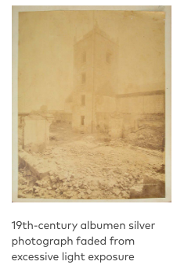
Light – best conditions
Source National
Gallery of Australia
(see references)
- The recommended light level for displaying
photographs at the Gallery is 50 Lux;
- UV-filtering acrylic glazing is generally
used instead of glass for framing photographs.
- The overall display time for photographs at the
Gallery is limited to three months every two years
to reduce cumulative light damage.

Temperature and relative humidity – potential damage
- Distortion of the photographic support and cracking or flaking of the emulsion layer.
- High temperatures will accelerate chemical deterioration processes in photographic materials, and at high humidity levels, gelatin layers can swell and become sticky, and mould can develop
- Low RH can also cause problems including embrittlement of the emulsion layers.
Temperature and relative humidity – best conditions
- Stable temp 21 degrees celcius

Dust accumulation and insect activity – potential damage
- Dust collected on the surface of a photograph can cause abrasion and scratching and may also contain chemical pollutants that react adversely with materials in the photograph.
- Insects are attracted to dust as a food source, but paper and photographic emulsions are also attractive.
Dust accumulation and insect activity – best conditions
- Photographs are best protected from dust and insects by storing them in well-sealed archival boxes, by displaying them in frames that have a good seal and by monitoring and addressing any insect activity.

Storage and display materials – potential damage
- Accelerated deterioration can occur if photographs are stored and/or displayed with inappropriate materials.
- Chemical pollutants are emitted into the immediate environment from poor quality materials such as PVC enclosures and albums, adhesives, unsealed wooden furniture, and freshly painted or varnished walls and furniture.
- Other materials such as woollen fabric linings, poor quality tissue paper and acidic cardboard mounts also cause deterioration from the ‘offgassing’ of chemical pollutants.

Storage and display materials – best conditions
- Photographs should be mounted and framed or interleaved and stored with archival quality chemically stable acid-free plastics such as polyethylene, polypropylene or polyester
- Archival paper products should be neutral pH, unbuffered and lignin, sulphur and peroxide free.
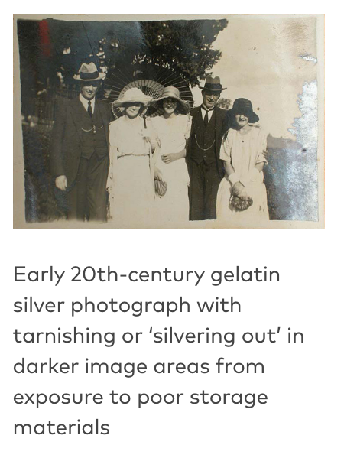

Handling – potential damage and best conditions
- All photographs can be physically damaged by careless handling, which may cause creases, tears, and losses. Sweat and oil from the skin deposited on photographs will also etch into the emulsion over time.
- Prevention: Wearing clean cotton gloves or nitrile/rubber gloves and using acid-free paper triangles to hold the edges of photographic materials can prevent this.

FOR WORKS ON PAPER
watercolours, prints, drawings, maps, documents, screens and scrolls
Works on paper will deteriorate at different rates, depending on when they were made and the materials and techniques that were used.

All processes of deterioration are affected by the environment – control of light, heat and humidity levels can significantly slow down the rate of deterioration.

- Acidity: A high level of acidity is probably the single most damaging factor for paper. typically it may become discoloured, brittle and develop disfiguring brown spot stains, known as foxing.

- Foxing usually evolves as a result of metallic impurities and micro-organisms in the paper.

Light – potential damage
- Natural light and fluorescent light sources are rich in ultra-violet radiation, the most active and damaging part of the spectrum.
- Sustained exposure to light can cause paper to become brown and brittle; pigments and inks can fade rapidly.
Light – best conditions
- Display works on paper in low light levels, well away from windows and strong light sources.
- The recommended museum level is 50 lux.
- Glazing in frames should be used to further protect the paper

Relative humidity and temperature – potential damage
- Excessive levels of heat and moisture in the air can be extremely damaging to works on paper.
- High humidity and temperature will accelerate the rate of acidic degradation of paper, in addition to encouraging mould growth
- In an environment where the humidity and temperature fluctuate dramatically, a cycle of expansion & contraction can be generated in the work of art, causing the support to cockle and the pigments to flake and crack.
Relative humidity and temperature – best conditions
- Circulation behind artworks to reduce risk of mould
- Regulate air temperature

Dust, insects and pollutants – potential damage and best conditions
- Insects will thrive in an undisturbed, dusty environment.
- Paper, together with sizes, adhesives and binders provide an ideal food source for insects.
- Dust can be abrasive and can retain chemical contaminants, which will degrade works on paper.
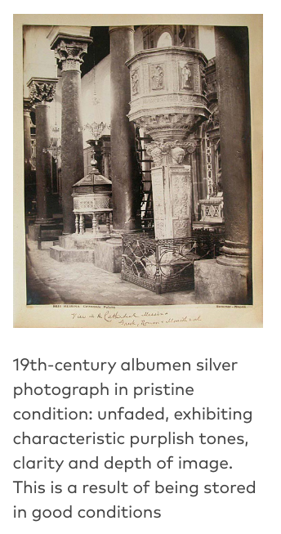
- Solution: Control air pollution and wipe surfaces regularly

FOR PAINTINGS

Light, heat, moisture, air pollutants, dust, dirt, insects, physical vibration and impact can lead to slow deterioration of, or sudden damage to, a painting.
Paintings in art galleries and museums are kept in conditions which protect them from those things which cause material deterioration.
Light – potential damage
- Light causes chemical changes in many materials used in paintings.
- The most obvious are the yellowing and darkening of varnishes and the discolouration of certain pigments
- Sustained exposure to ultra violet rays found in natural light is the most damaging.

Light – best conditions
- Museums and galleries minimise natural daylight and use light which filters out UV to display works.
Relative humidity and temperature
Paintings are essentially layered objects, built up from canvas, ground layer, paint layers and varnish layers. The layers contain materials which have differing physical characteristics including the rate at which they expand and contract at varying temperatures and the rate at which they take up moisture from the surrounding air.
Potential damage
- Fluctuations in temperature and humidity set up cycles of expansion and contraction which will inexorably lead to the deterioration of paintings

Relative humidity and temperature – best conditions
- The museum standard temperature for keeping paintings safe is 20ºC ± 1ºC.
- The accepted museum standard for relative humidity is 50% ± 3%.
- A constant climate is therefore the ideal situation for keeping works of art stable.
- Museums and galleries have sophisticated air-conditioning systems in place to maintain constant environmental conditions.
Dust, dirt, air pollutants and insects – potential damage and best conditions
- Dust is composed of minute particles including some hard substances that can scratch paint or varnish if rubbed against the surface of a painting.
- Some types of dirt, including insect debris, can contain acidic components that eat into the paint surface.
- Similarly, industrial air pollutants can affect the paint or the finish on a frame.

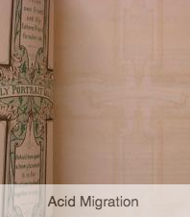
OTHER FORMS OF DAMAGE
https://aiccm.org.au/conservation/visual-glossary
Acid migration
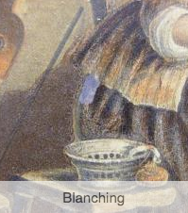
- The transfer of acidic substances between
two surfaces in contact with each
other; often causing localised
staining and discolouration.
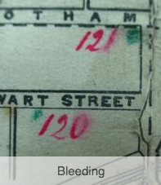
- Also called acid transfer.

Blanching
- Where a previously clear and
transparent surface (eg. A varnish)
has become white and/or opaque.
- Similar in appearance to bloom.

Bleeding
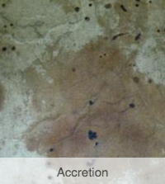
- Where an ink, paint or dye has become partially soluble and
has wicked into surrounding areas of support
(usually textile or paper) resulting in a “blurry” appearance.

Accretion
- A solid piece of foreign matter attached
to the surface of an object.

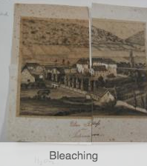
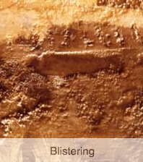
Bleaching
- Where a material becomes lighter in colour
due to a action of various solvents or light.
- Sublight, especially the ultraviolet component,
can be particularly damaging.

Blistering
- Raised area, bulge or bubble on the
surface of an object, often between
adjoining layers of different materials.
- Most likely caused from a loss of adhesion
between layers, excessive heat or pockets of air or liquid.
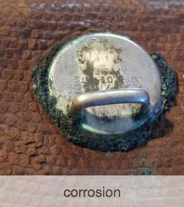
Corrosion
- Gradual deterioration of solid (especially metals)
due to chemical processes such as oxidation or
the action of a chemical agent.
- Some corrosive products are harmful, eg. Rust
- Corrosion is often accelerated by content with
materials that generate acidic vapours eg. Wood, plastics

TEXTILE conservation:
Textile conservators use microscopes and other equipment to identify fibers, yarns, weaves, and dyes and to determine what restoration materials should be used to repair a particular textile.

They are also skilled in spinning, weaving, and sewing

Conservation & Presentation Key Terms:
Relative Humidity | 55rh +/- 5%  21* +/- 2* | The percentage of water in the air. Measured by a thermohydrograph (also temperature)
Lux | 50% +/- 5% | The levels of UV light
Acid Free |  | Paper that if infused in water yields a neutral or basic pH  (7 or slightly greater)
Resting |  | Fragile works (on paper, fabric or organic matter) need to be stored in darkness for a 1:3 ratio (eg. 1 month on display = 3 months in storage)
Preventative Conservation |  | Use of psychological barriers and physical barriers
Curatorial Key Terms:
Didactic panels |  | Wall text beside artworks and other large panels.  Can refer to it as “wall text”
Mount |  | The card insert to create distance and space between a frame and the artwork

