COLOUR

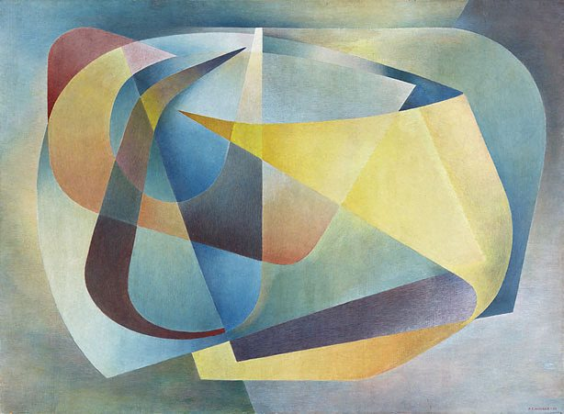
Plate 1 Frank Hinder Abstract painting 1957

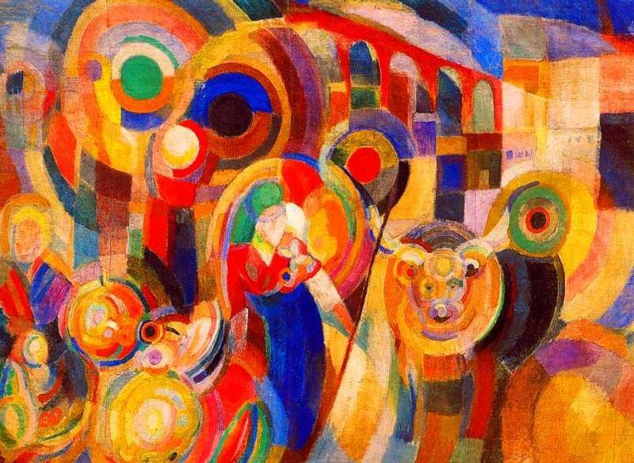
Plate 2 Sonia Delaunay Market at Minho 1916

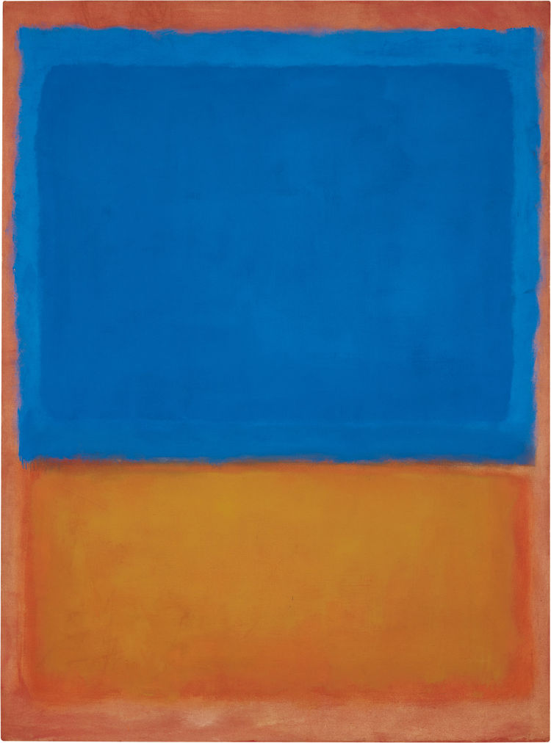
Plate 3 Mark Rothko Untitled (Blue & Orange) 1955

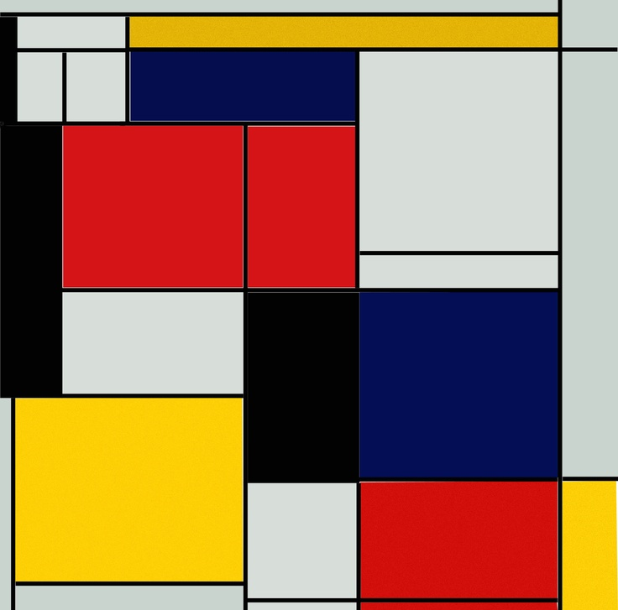
Plate 4 Piet Mondrian Composition in Red, Blue and Yellow 1930
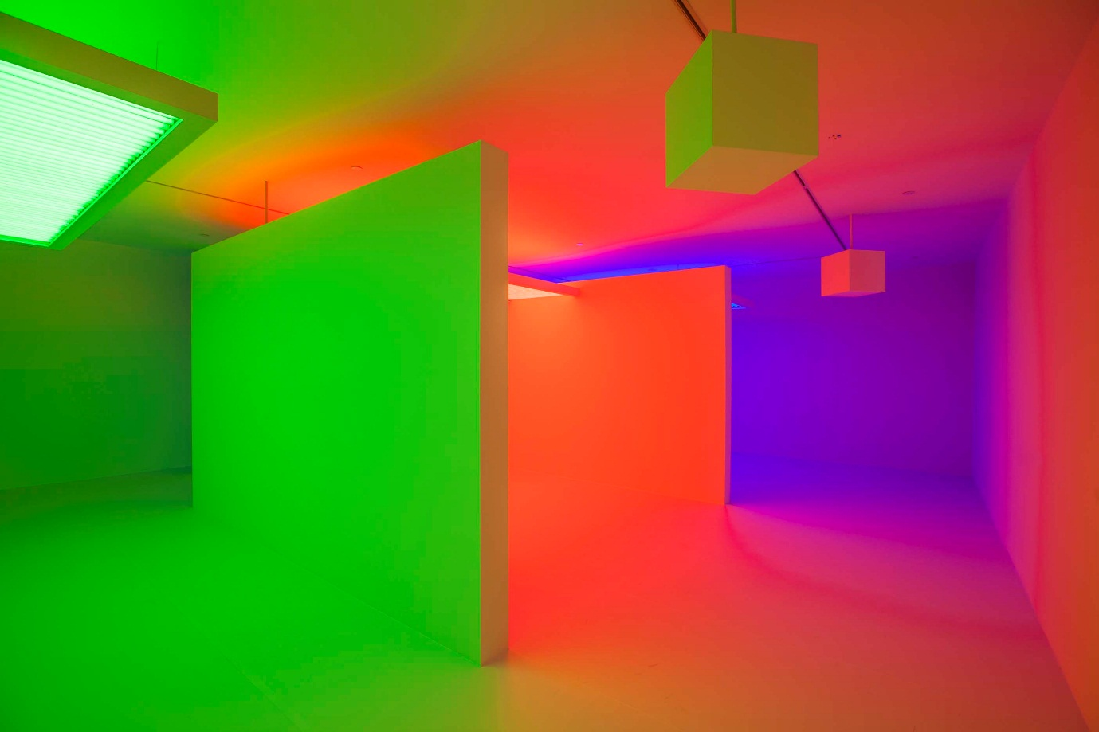
Plate 5 Carlos Cruz-Diez Chromosaturation 2015

Plate 6 Kazimir Malevich Black Square 1915

